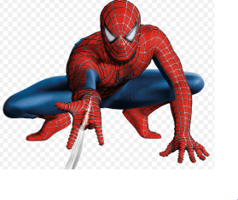 | 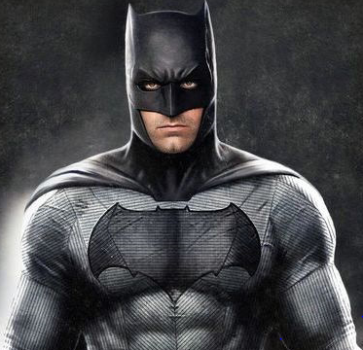
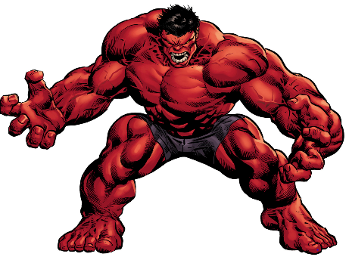 | 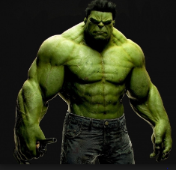
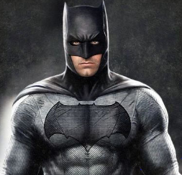 | 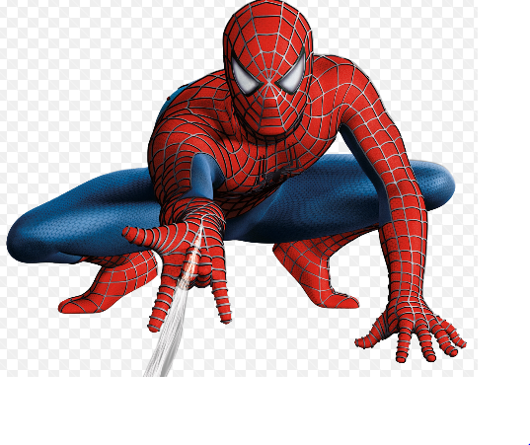
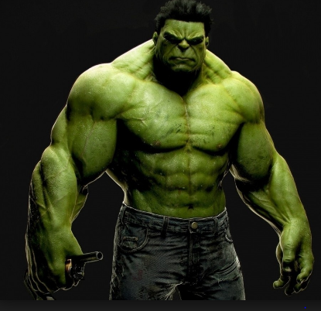 | 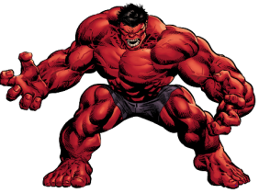

Instructions
You will need
2 x copies of the Superheroes sheet
2 x 8 counters or cubes
A barrier eg large book

Step 1
Put the Superheroes sheets either side of the barrier and give each player 8 counters.
Check that each player can name the Superheroes.
Take it in turns to give each other an instruction to put a counter on a picture eg Put a counter on the big Spiderman, put a counter on the little Batman – until all the counters are used up.
If you don’t hear properly or don’t understand the instruction you can ask the other person to repeat what they have said.
Step 2
To make it slightly harder – use different coloured counters. So the instruction will be ‘put a red counter on the big Green Hulk, put a green counter on the big Batman’.
When the counters are used up remove the barrier and see if the two sets of counters are in the same place.

